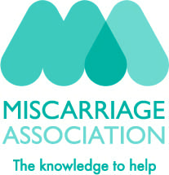

2 Otters Holt, Durkar, Wakefield, WF4 3QE
Tel: 01924 200799 Charity Number: 1076829 SC039790 www.miscarriageassociation.org.uk
Miscarriage can be a very distressing, frightening and lonely experience. The Miscarriage Association is a national charity providing support and information to anyone who is affected by the loss of a baby in pregnancy. We work with health professionals to promote good care and support research into the causes and treatment of miscarriage. Your sponsorship money will help fund our helpline, a national network of support volunteers, and a wide range of leaflets on the facts and feelings of pregnancy loss.
Thank you for your support.

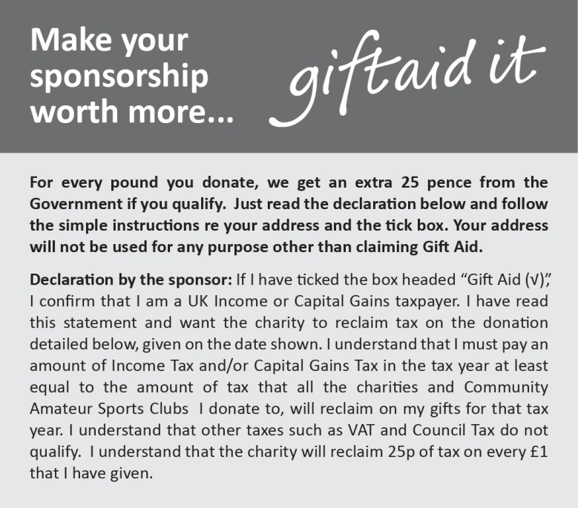
Please return this form to Fundraising at the above address

Please sponsor who has pledged to take 250,000 steps in January 2025 as part of our Step Up campaign to raise funds and awareness for the Miscarriage Association

Full Name  (First name & surname) | HOME Address  Required If ticking Gift Aid | HOME Postcode  Required If ticking Gift Aid | Amount  £ | Date Paid | Gift  Aid?  √
CHARITY
USE ONLY
 | Total donations received >  { | £
 | Total Gift Aid donations > | 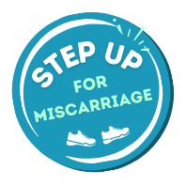  £
 | Date donations given to Charity >

2 Otters Holt, Durkar, Wakefield, WF4 3QE
Tel: 01924 200799 Charity Number: 1076829 SC039790 www.miscarriageassociation.org.uk
Miscarriage can be a very distressing, frightening and lonely experience. The Miscarriage Association is a national charity providing support and information to anyone who is affected by the loss of a baby in pregnancy. We work with health professionals to promote good care and support research into the causes and treatment of miscarriage. Your sponsorship money will help fund our helpline, a national network of support volunteers, and a wide range of leaflets on the facts and feelings of pregnancy loss.
Thank you for your support.

Please return this form to Fundraising at the above address

Please sponsor who has pledged to take 250,000 steps in January 2025 as part of our Step Up campaign to raise funds and awareness for the Miscarriage Association

Full Name  (First name & surname) | HOME Address  Required If ticking Gift Aid | HOME Postcode  Required If ticking Gift Aid | Amount  £ | Date Paid | Gift  Aid?  √
CHARITY
USE ONLY
 | Total donations received >  { | £
 | Total Gift Aid donations > | £
 | Date donations given to Charity >

