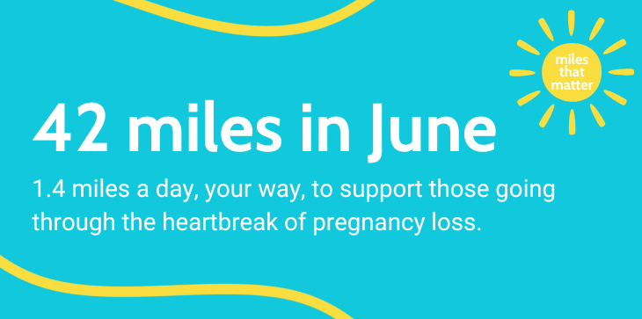
2 Otters Holt, Durkar, Wakefield WF4 3QE
Tel: 01924 200799 Charity Number: 1076829 SC039790 www.miscarriageassociation.org.uk

Miscarriage can be a very distressing, frightening and lonely experience. The Miscarriage Association is a national charity providing support and information to anyone who is affected by the loss of a baby in pregnancy. We work with health professionals to promote good care and support research into the causes and treatment of miscarriage. Your sponsorship money will help fund our helpline, a national network of support volunteers, and a wide range of leaflets on the facts and feelings of pregnancy loss.
Please sponsor ____________________________ who is taking part in our Miles that Matter

fundraising campaign during June 2025
Full Name  (First name & surname) | HOME Address  Required If ticking Gift Aid | HOME Postcode  Required If ticking Gift Aid | Amount  £ | Date Paid | Gift  Aid?  √
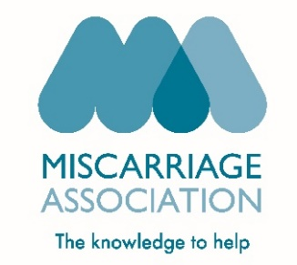
CHARITY
USE ONLY
{
 | Total donations received > | £
 | Total Gift Aid donations > | £
 | Date donations given to Charity >

